**Go to market Strategy**

Success metric, who, what, Adjective, when, where

1. Success metric -
   1. Define goals - traffic, total active users, unbounce rate
   2. Time period
2. Who - people who are potentially interested in the product or service being offered on the landing page. They may have clicked on an ad, social media post or search result and are looking for more information.

Education

Real estate

Feedback surveys

* 1. target user
  2. Prioritize - frequency, spend

1. What do you as a product known for - adjective
   1. easy to use, customisable
2. Where - for notifice mostly indian market
   1. From where users come from
   2. Innovation - silicon valley
3. When -
4. Value propagation - Save time and money with our all-in-one software solution for small businesses.
5. Inbound and outbound marketing -
   1. Inbound - target the specific audience and customer - social media post, blogs
   2. Outbound - designed to capture customer attention and sell the product - direct mail, ads, billboards etc.
6. Content -
   1. Blogs

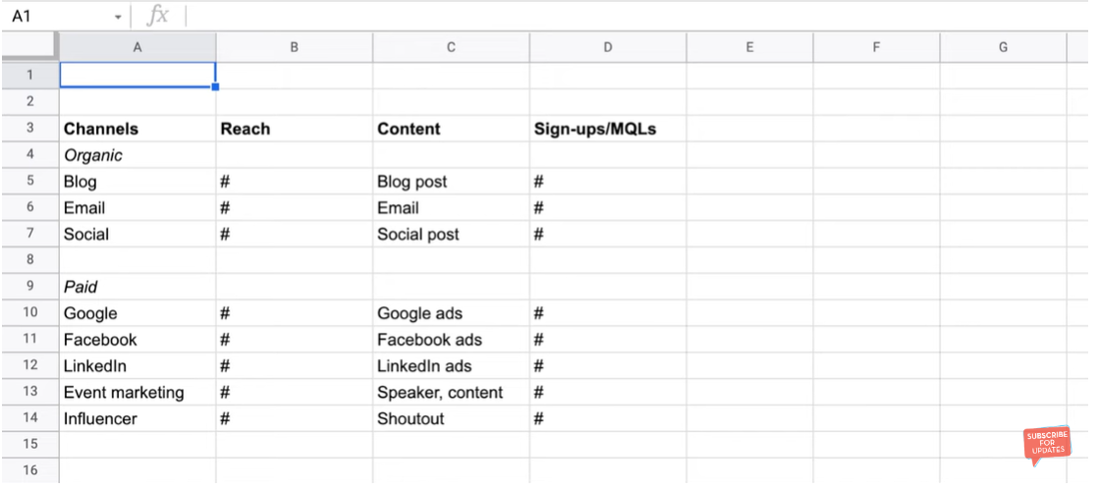

Pre launch giveaway - also from launch we are able to generate some user content

Blogs - create high quality content to attract more organic view

Social media influencers - marketing from social media

Prepare faqs before launch - because users has bunch of questions how it works

Email marketing

**GTM Product features**

1. Usability: The product should be user-friendly - design, easy to use, meets the need of user
2. Functionality: The product should meet the needs of the target audience by providing the necessary features and capabilities.

Customisable - A/B splitting - general report -> total pages, total views, total variant

1. Design: The product should have an attractive design that catches the attention of potential customers. The packaging, branding, and overall aesthetics should be appealing and visually pleasing.
2. Performance: The product should perform well and deliver the promised results. It should be efficient and effective in solving the problem it was designed to address.
3. Price - not available for notifice
4. Customer support - request demo one to one, support page
5. Compatibility: The product should be compatible with different operating systems, devices, and software applications. This ensures that customers can use the product on the platform of their choice.
6. Innovation: The product should be innovative and offer a unique value proposition. It should stand out from competitors and offer something new and exciting to the market

**GTM Strategy**

4p - price, product, placement, promotion